**ARTIFICIAL INTELLIGENCE REPORT**

**Automatic Vehicle Numberplate Recognition**

**Submitted by:**

Tanisha Jain 102103611

Harsukhdit Singh 102103670

***PROBLEM STATEMENT:***

To detect and extract characters of vehicle number plates.

***DESCRIPTION OF PROBLEM:***

The objective of this project is to design an efficient automatic authorized vehicle identification system by using the vehicle number plate. The CCTV camera can be placed at any busy location/building, airports and railway stations, college and institutions and capture images of passing vehicles in and out of their territory. The captured images then get stored in a google drive where our project accesses them. They then identify the number plate of the vehicle and stores it. The number plate of a vehicle tells us the registration of the vehicle, model and day it was bought. In case of theft or a crime, it can be hopefully easier to identify the criminal responsible.

We can also install the camera on busy and accident-prone areas to monitor traffic and issue challans to anybody flouting the traffic rules (over-speeding, jumping red lights, hit and run cases, etc). This will be helpful to the police officers who cannot stay on guard at traffic lights due to less staff or a busy day.

It does not register the time when the picture was taken which we hope to add in the future, to make this project more useful.

***INTRODUCTION:***

Vehicle Number Plate Recognition (VNPR) is a technology that uses optical character recognition on images of vehicle registration plates to read the vehicle’s registration number. An automatic license plate recognition system applies different image processing techniques to identify vehicles quickly and automatically in images or real-time video of one or multiple cameras.

A vehicle license plate recognition system can be used for a variety of purposes, such as tracking the movement of vehicles, identifying specific cars, automated parking enforcement, and so on. The use of VNPR systems is becoming more popular as the technology advances rapidly with the advent of machine learning and deep learning, the computational cost decreases, and the accuracy of applied image processing techniques increases.

***CODE AND EXPLANATION:***

(Approach to our problem statement)

1. Downloading the vehicle images from google drive to a given folder.
2. Turning an image to Grayscale.
3. Applying Bilateral Filter to images to reduce noise and preserve edges.
4. Applying Edge Detection to identify boundaries(edges) of objects and regions.
5. Finding Contours in image and applying mask to output the region of interest.
6. Cropping the image to get (ROI) number plate.
7. Using EasyOCR to read text from an image of a number plate cropped.
8. Printing the result.

*Link to our code:* <https://colab.research.google.com/drive/1jl8yUoie7U0VfgGgOLvzxkWmAraT-Jh5>

*Link of our Google Drive Folder:*

<https://drive.google.com/drive/folders/1kqcldID6C2wjCV6dKUu2Gt2xCbexyYe1>

Dataset Used: [Car License Plate Detection | Kaggle](https://www.kaggle.com/datasets/andrewmvd/car-plate-detection)

**Image of directory after importing images:**

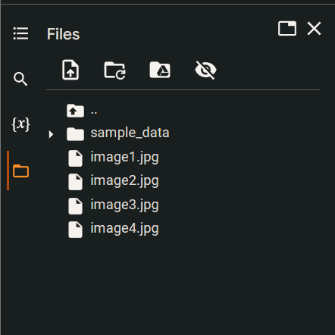

**Using gdown Function to import pictures from Google Drive**

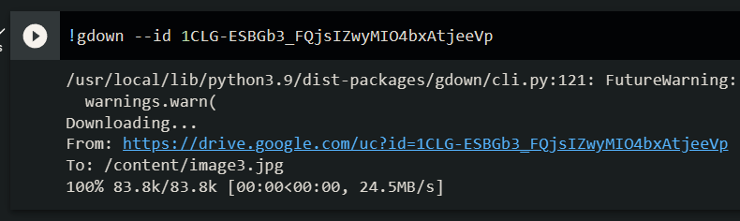

**Using pip install command to install easyocr and imutils to Google Colab:**

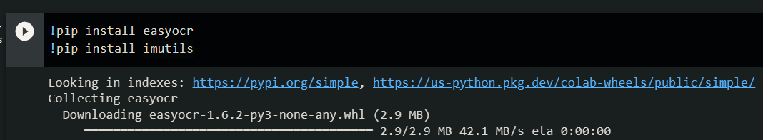

***USED MODULES/LIBRARIES:***

1. *OpenCV:*

OpenCV is the huge open-source library for computer vision, machine learning, and image processing and now it plays a major role in real-time operation which is very important in today’s systems. By using it, one can process images and videos to identify objects, faces, or even handwriting of a human. When integrated with various libraries, such as NumPy, python is capable of processing the OpenCV array structure for analysis. To Identify image pattern and its various features we use vector space and perform mathematical operations on these features.

1. *Matplotlib:*

Matplotlib is an amazing visualization library in Python for 2D plots of arrays. Matplotlib is a multi-platform data visualization library built on NumPy arrays and designed to work with the broader SciPy stack. It was introduced by John Hunter in 2002. One of the greatest benefits of visualization is that it allows us visual access to huge amounts of data in easily digestible visuals. Matplotlib consists of several plots like line, bar, scatter, histogram etc.

1. *Numpy:*

NumPy is a general-purpose array-processing package. It provides a high-performance multidimensional array object, and tools for working with these arrays. It is the fundamental package for scientific computing with Python. It is open-source software. It contains various features including these important ones:

* A powerful N-dimensional array object
* Sophisticated (broadcasting) functions
* Tools for integrating C/C++ and Fortran code
* Useful linear algebra, Fourier transform, and random number capabilities

1. *Imutils:*

A series of convenience functions to make basic image processing functions such as translation, rotation, resizing, skeletonization, displaying Matplotlib images, sorting contours, detecting edges, and much more easier with OpenCV and both Python 2.7 and Python 3.

1. *EasyOCR:*

EasyOCR is a Python library for Optical Character Recognition (OCR) that allows you to easily extract text from images and scanned documents. In this tutorial, we will understand the basics of using the Python EasyOCR package with examples to show how to extract text from images along with various parameter settings.

***IMPORTING LIBRARIES:***

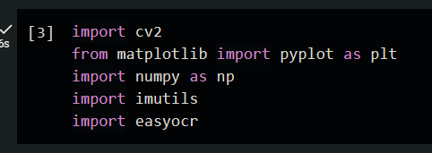

***CONVERTING IMAGE IN GRAYSCALE:***

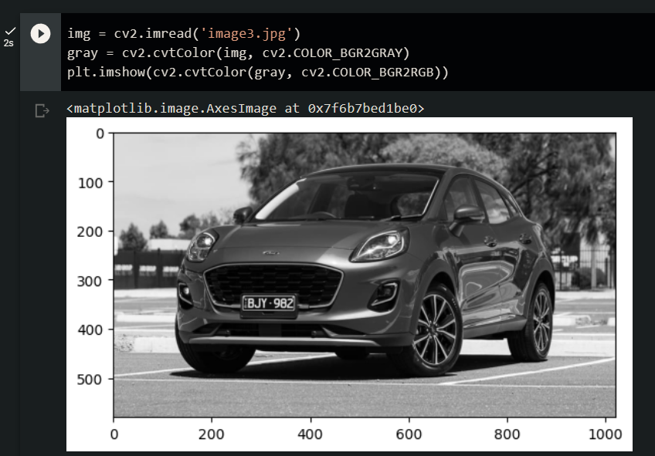

***APPLYING FILTER AND FIND EDGES FOR LOCALIZATION:***

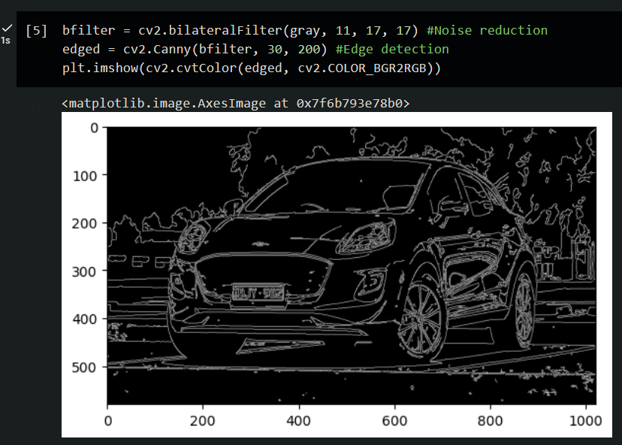

***FINDING CONTOURS:***

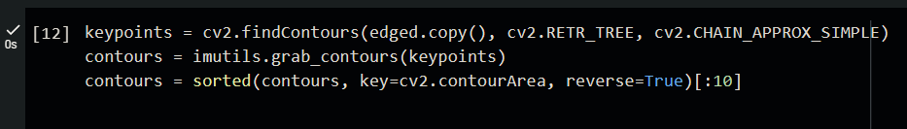

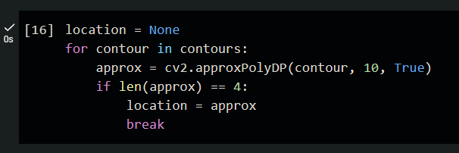

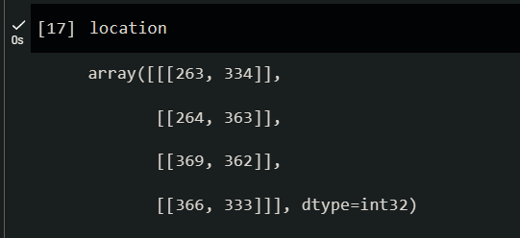

***APPLYING MASK:***

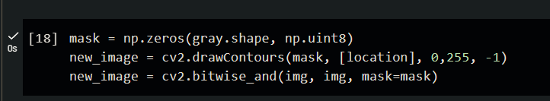

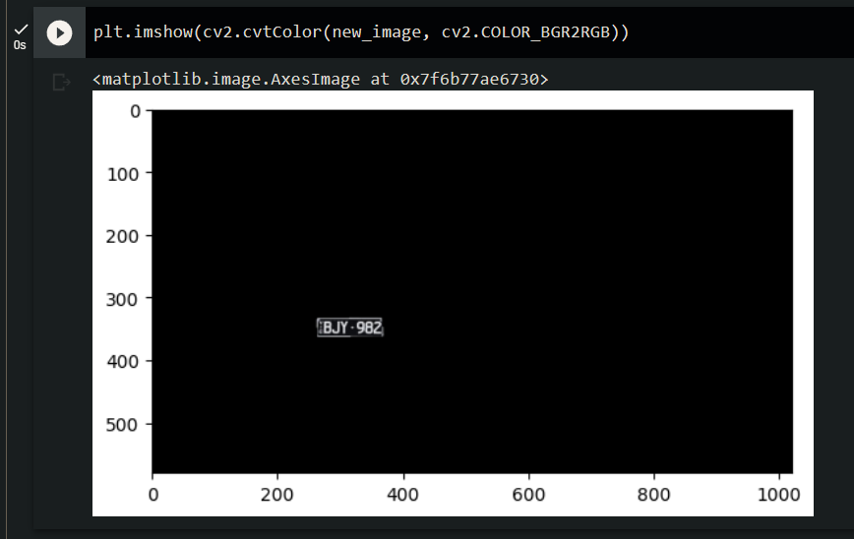

***FINDING LOCATION OF THE NUMBERPLATE AND CROPPING IT:***

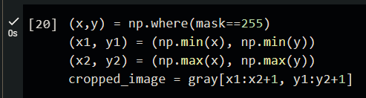

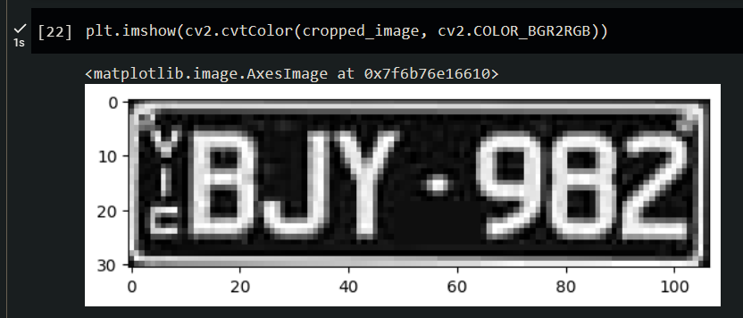

***USING EasyOCR TO READ TEXT:***

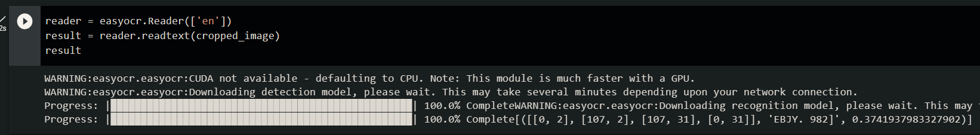

***OUTPUT->*** 

***PRINTING RESULT:***  
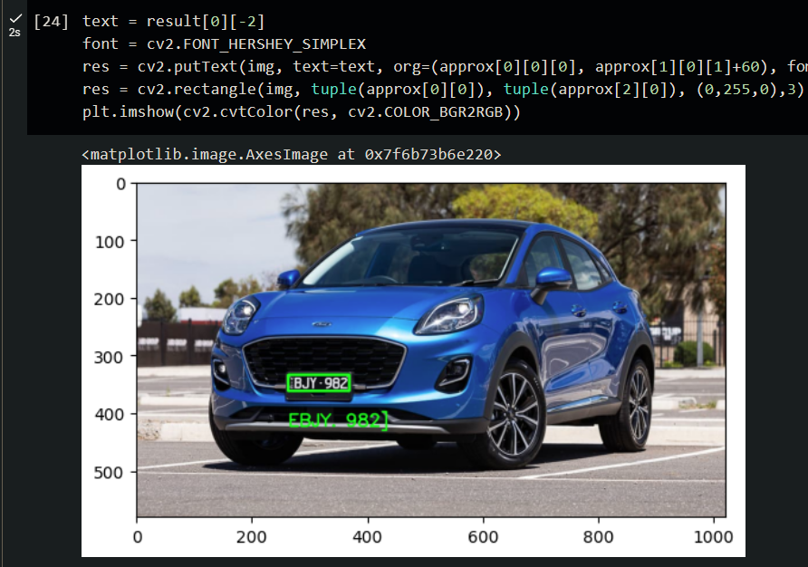

***FLOWCHART:***

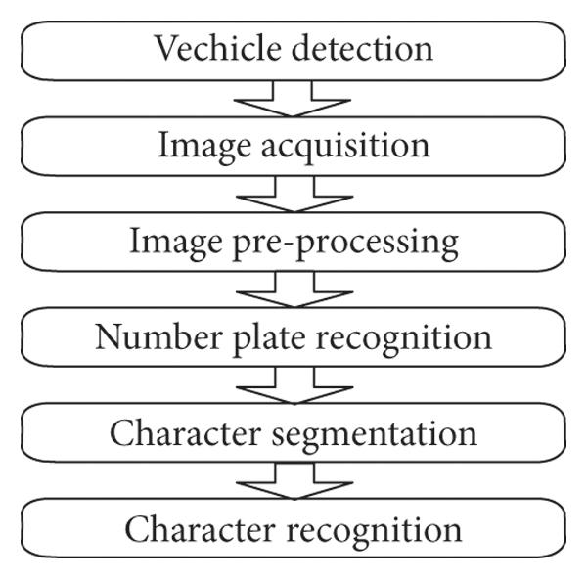

***FUTURE SCOPE:***

1. The future scope is that the automatic vehicle recognition system plays a major role in detecting threats to defense Also it can improve the security related to the women as they can easily detect the number plate before using a cab or other series. The system robustness can be increased if a bright and sharp camera is used. Government should take some interest in developing this system as this system is money-saving and eco- friendly, if applied effectively in various areas...
2. The system can be enhanced using sensors at the entrance. As any vehicle enters the gate it first captures the image of its number plate. Then the image is sent to the program and then to the database where it is categorized. If the number plate matches then the gate would open, else it will send an alert.
3. Environmental benefits: The use of an VNPR system can help reduce traffic congestion and pollution by discouraging unnecessary driving. Reducing waiting times, or time to search for parking spaces in cities helps decrease the environmental pollution.
4. Identification: Fast recognition of a vehicle number plate is the basis for fast and seamless vehicle identification. The identification can be used to grant vehicles access or find and track specific vehicles.
5. Versatility: Automated vehicle identification can be applied for a variety of applications, from parking management to security, traffic enforcement, logistics optimization in manufacturing, and so on.
6. Security: VNPR solutions are of great importance for various security and surveillance applications of computer vision. Such systems help improve security by providing a method to identify and track multiple vehicles autonomously.

***LITERATURE SURVEY:***

* [Vehicle Number Plate Recognition System: A Literature Review and Implementation using Template Matching (psu.edu)](https://citeseerx.ist.psu.edu/document?repid=rep1&type=pdf&doi=cf4e319d05676ecc593abd3c9c97503545510262)
* [Automatic Number Plate Recognition System (ANPR): A Survey (researchgate.net)](https://www.researchgate.net/profile/Chirag-Patel-12/publication/236888959_Automatic_Number_Plate_Recognition_System_ANPR_A_Survey/links/02e7e519f300c92954000000/Automatic-Number-Plate-Recognition-System-ANPR-A-Survey.pdf)
* [Microsoft Word - 23_56-B-카드_0227-OK__인도 Copyright Accepted_ 0214 Number Plate Recognition (researchgate.net)](https://www.researchgate.net/profile/Sandipan-Narote/publication/265991428_Number_Plate_Recognition_for_Indian_Vehicles/links/54b888460cf2c27adc48c4bc/Number-Plate-Recognition-for-Indian-Vehicles.pdf)
* [27-394-libre.pdf (d1wqtxts1xzle7.cloudfront.net)](https://d1wqtxts1xzle7.cloudfront.net/31062562/27-394-libre.pdf?1392228804=&response-content-disposition=inline%3B+filename%3DVehicle_number_plate_recognition_using_m.pdf&Expires=1682552832&Signature=SfS04D-8V5Qsrxlf-JTek4mxsZi-EKnqBrcxCDRHL5KTzrdDBWOi9dA0FE~eWHQ7mK2CTr2vRthPW4ZGVJVUg~KpfbZpb~gza~xqeqCiugcv3eCvH2K32dwkJZtvMT1ZjlFM7lwBTG1VuePqr73iXdvRqxiV1pzUKRleP4dwfwE7jRcmOLfr4EprfUuYgJZAh-1EVRCOSBnzu40B7vOrrJK5EKc19PwC8Uez35gT-4FUR46ZPmQG7aqTNQTpND6B8Znz1A~gMfhs4t-cqmeHg6ectm499K4FTTV569wXYFdjRmtasE9F2FZFQpmmdMtkTrJCNHx0pQkri1BTjZyoYw__&Key-Pair-Id=APKAJLOHF5GGSLRBV4ZA)
* [Performance Analysis of Vehicle Number Plate Recognition System Using Template Matching Techniques (researchgate.net)](https://www.researchgate.net/profile/Gajendra-Sharma/publication/325362213_Performance_Analysis_of_Vehicle_Number_Plate_Recognition_System_Using_Template_Matching_Techniques/links/5b90d50f45851540d1d1315a/Performance-Analysis-of-Vehicle-Number-Plate-Recognition-System-Using-Template-Matching-Techniques.pdf)
* [NUMBER_PLATE_RECOGNITION_USING_OCR_TECHNIQUE-libre.pdf (d1wqtxts1xzle7.cloudfront.net)](https://d1wqtxts1xzle7.cloudfront.net/32411864/NUMBER_PLATE_RECOGNITION_USING_OCR_TECHNIQUE-libre.pdf?1391610449=&response-content-disposition=inline%3B+filename%3DNUMBER_PLATE_RECOGNITION_USING_OCR_TECHN.pdf&Expires=1682553038&Signature=X-3Vz3e8NAF4cx14IQMDtpLczwwftr62eWrLvcns7dkGxtwbkdGqhaBlDz0Dzi151WX-7r1nFAxeKwHUw9spBZtkia7sS8BSrpPK6AXiw81g-EzhMrV5wcCYDzbJRPXybMkFbCiDpYKI359kJA9RWy5Ayo589yHGJzPJtRbSq~orxxAW6HpRrT7dHA-aVlXz5x0J2ewMlMpHyHRR0vhcrf7RUSQBca7enVqxvDHcXorCCZYN6TDoh6uCMs5j~HGcsDcuumzIGsSaujazXAh4wvmkehrW2IAE6~IBSCfR2G6QEibK64J6PzJR--f-BdTofW2DPRuQMQ~UYVGMOGmPIw__&Key-Pair-Id=APKAJLOHF5GGSLRBV4ZA)
* [IJCTEE_0811_07-libre.pdf (d1wqtxts1xzle7.cloudfront.net)](https://d1wqtxts1xzle7.cloudfront.net/46684964/IJCTEE_0811_07-libre.pdf?1466538818=&response-content-disposition=inline%3B+filename%3DVehicle_number_plate_recognition_using_m.pdf&Expires=1682553041&Signature=SWSJ~bX8j784H2pKLInmpOzF7JeqkZOMCpIjMewsGiEWgKaGU-uokSQeD2WYCQtjluGzKeJ6GvD7SbUhdZj~gg9rFDpN1AYnYbFSS0mw31ojHFstPyTMIF08UvbBppM7qYx9HruE0mwg3ddTwS9tS6gfJ8jKO6UQSZrGeDJTbmI6cXEzK3lwdAOTf2Tx9fUuuXm823~IrynSIad8D~fnfc9jcL9o35hafmkEry1YFnvVxL2AO~1nD43xDprZVeBsA~YXubYJZ7JuYd3kkaQVNcko3pNRd6lJUhp7m3DF~-ywOfCdwZEpdTuGg9GyroxYgcdG1lIP312Bkr0feqCnQQ__&Key-Pair-Id=APKAJLOHF5GGSLRBV4ZA)
* [document (psu.edu)](https://citeseerx.ist.psu.edu/document?repid=rep1&type=pdf&doi=d2f7c995362aafc36c94bdce44c6a6ac24bd8973)
* [(iaeng.org)](https://www.iaeng.org/publication/WCECS2012/WCECS2012_pp199-203.pdf)